
14th Annual
I Hear Music in the Air Conference
May 19th, 2017
Special guest
Kirk Franklin

2017 SPONSORSHIP PACKAGE

2014 theme
I Hear Music, Inc.
11804 Conrey Rd – Ste 150
Tel 513-247-0205
Fax 513-247-0999
www.ihearmusicintheair.com

Table of Contents
A Message from the Founder 1
Demographics & Marketing Efforts 2
Contribution Levels 3
Contribution Levels 4
Contact Information 5

A Message from the Founder

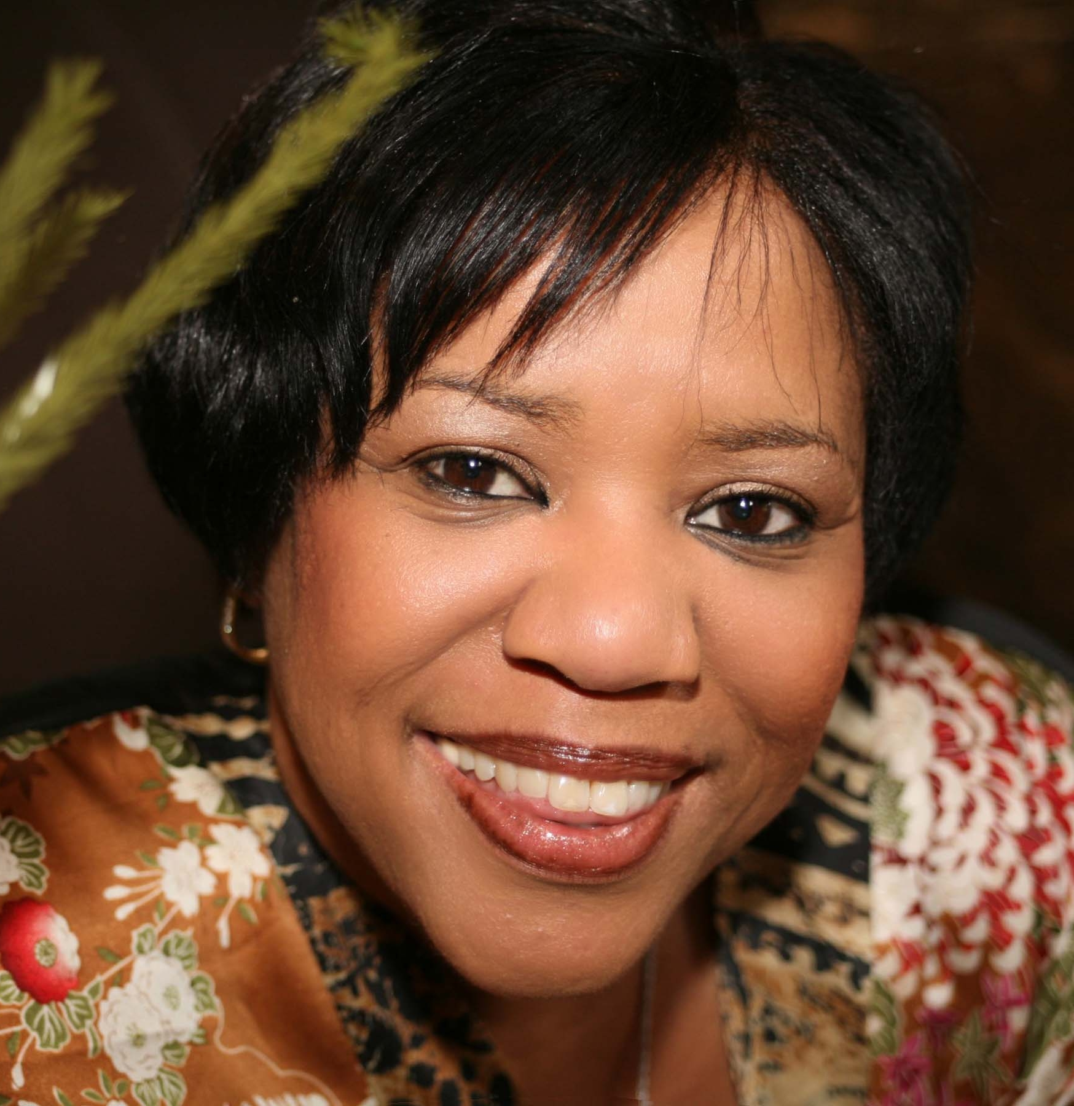
Tracey Artis, Founder & CEO

For the 14th year, I Hear Music in the Air will gather in Cincinnati to celebrate with thousands from across the country for an exciting weekend to honor, educate, and enjoy music and ministry from leaders and top artists in the Gospel industry.

Our praise-filled weekend will include something for everyone – a concert featuring local, regional and national standouts in the industry such as Donnie McClurkin, William McDowell, Isaac Carree, Israel Houghton, and Rodney Posey, a mastery class full of information for those who would like to learn more about the Gospel music industry, Bishop Hezekiah Walker’s Choir Fest®, and culminating in the Legend’s Ball, which celebrates leaders in the field.

We would like to give you the opportunity to reach this important audience by sponsoring I Hear Music in the Air Conference 2017. In the following pages, we’ll share information about various sponsorship levels. We can also customize a sponsorship packet to meet your special needs. Thank you in advance for your support.

About Tracey Artis: Entrepreneur and Gospel Music Industry Executive Tracey Artis is a pioneer in her own right. Since her break into the music industry in 1996 at AIR Gospel, Artis has helped drive the success of some of contemporary Gospel music’s biggest names including Byron Cage, J. Moss, Marvin Sapp, Donnie McClurkin, Fred Hammond, Andrae Crouch, Kirk Franklin, Kurt Karr, Dorinda Clark, Mary Mary, Charles Jenkins, and Israel Houghton, just to name a few. Founded in 1999, I Hear Music Inc., is a promotions and marketing firm that represents gospel artists and produces special events such as the Urban League Evening of Faith, The Health Care Connection Jazz Benefit, and her signature event; The I Hear Music in the Air Conference. Although a woman of high stature, Artis’ humbleness is a feat that far outweighs her many accomplishments. Her entire outlook on life can be summed up with the phrase, “Only what you do for Christ will last.”

Demographics & Marketing Efforts

demoGrahPhics
Your organization will be exposed to at least 10,000 regional, national and international participants at the event
  - Women, men, and children of all ages
  - Primarily African-American

Radio Promotions
Informative commercial spots and purchased time buys will be one of the premier promotional resources that will be used to reach participants across the country. These commercial spots will be strategically placed on radio outlets in order to reach the optimum amount of listeners.

Marketing Efforts
Our marketing efforts will be deliberate and pointed in order to raise maximum consumer awareness. Your company logo will be featured on all marketing pieces. Efforts include, but are not limited to the following:
- E-Marketing:
  - E-Blasts
  - Web Banners
  - Social Media
  - Press Releases
  - I Hear Music in the Air Website
  - Media Coverage
  - Media Sponsors
- Physical Merchandise:
  - Post Cards
  - Street Teams
  - Posters
  - Flyers
  - Signage
- Product Placement & Exhibits
  - Vendor Booths
  - Product Placement in I Hear Music Gift Bags
  - Music playing throughout the weekend at various events
- Community Involvement:
  - WGRI-AM – Cincinnati, OH, WCVG-AM Latonia, KY, Radio One Cincinnati, OH, WDAO-AM Dayton, OH, WCNB Dayton, OH
  - Buck Eye Calendar
  - Church Announcements

Contribution Levels

Delegate sponsor - $1,000.00
- Name on printed material
- Acknowledgement at sessions
- Venue Signage
- Two complimentary passes to workshop
- Two complimentary passes to all VIP events
- Exhibit space at workshop

BRONZE SPONSOR - $2,500.00
- Name on printed material
- Quarter-page ad in the souvenir program
- Three complimentary passes to all VIP Events
- Three complimentary passes to workshop
- Venue Signage
- Exhibit space at workshop
- Opportunity for company employees to volunteer
- Product/Flyers placed in souvenir bags

SILVER SPONSOR - $5,000.00
- Name on print advertising for I Hear Music in the Air
- Exhibit booth space at all events
- Half-page ad in the souvenir program
- Four complimentary passes to all VIP events
- Two seats for the Legends Ball
- On-stage recognition and endorsement at concert
- On-site signage
- Opportunity for company employees to volunteer

Contribution Levels

gOLD SPONSOR - $10,000.00
- Your logo on all printed materials for I Hear Music in the Air
- Sponsor credit on radio advertising
- Exhibit booth space at all events.
- Full page ad in souvenir program
- Six complimentary passes to all VIP events
- Four seats for the Legends Ball
- On-stage recognition and endorsement at the concert
- On-site signage
- Opportunity for company employees to volunteer
- Opportunity to place items in goodie bags

tITLE SPONSOR - $15,000.00
- Naming-rights sponsorship of I Hear Music In The Air 2014, incorporating your company logo in all signage and promotional material
- 5-minute presentation at opening day event
- Sponsor credit on radio advertising
- Exhibit booth space at all I Hear Music in the Air Events during all 3 days
- Full page in the advertisement in the souvenir program)
- Two 1 minute spots on related television programs
- 10 complimentary passes to all VIP events
- One VIP table (8 seats) for the Legends Ball
- On-stage recognition and endorsement at all venues
- Product category exclusivity
- On-site signage
- Opportunities for company employees to volunteer backstage at the events
- Opportunities to place items in goodie bags

Contact Information

I Hear Music, Inc.
11804 Conrey Rd – Ste 150
Tel 513-247-0205
Fax 513-247-0999
www.ihearmusicintheair.com

